**LAB ASSIGNMENT #4**

**(a)**

**STATEMENT:** WRITE A PROGRAM TO FIND THE PRODUCT OF ANY 10 NUMBERS USING POINTER, ARRAY AND FUNCTION.

**ALGORITHM:**

Step-1: Start

Step-2:

Step-3:

Step-4:

Step-5:

**SOURCE CODE:**

#include<stdio.h>

#include<conio.h>

void main()

{

int *x,i;

long int j=1;

long int product(int *x);

clrscr();

printf("\n Enter 10 Numbers: \n");

for(i=0;i<10;i++)

scanf("%d",x+i);

j=product(x);

printf("\nThe product of given numbers is=%ld",j);

getch();

}

long int product(int *x)

{

int i;

long int j=1;

for(i=0;i<10;i++)

{

j=j* *(x+i);

}

return j;

}

**OUTPUT:**

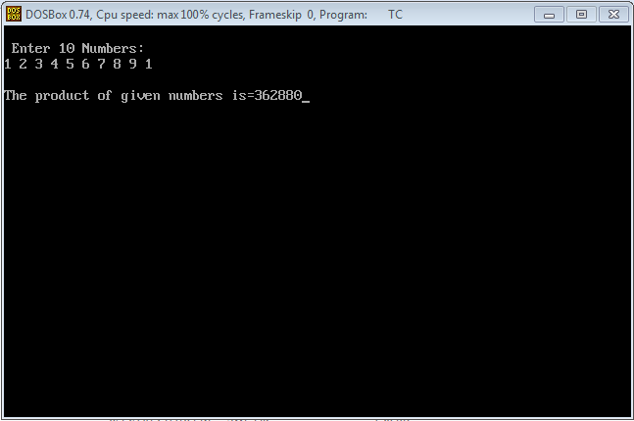

**CONCLUSION:** Hence, the program was successful, and the product of any 10 numbers was found using pointer, array and function.

**(b)**

**STATEMENT:** WRITE A PROGRAM TO FIND THE SUM OF ANY TWO 3*3 MATRIX USING DYNAMIC MEMORY ALLOCATION.

**ALGORITHM:**

Step-1: Start

Step-2:

Step-3:

Step-4:

Step-5:

Step-6:

**SOURCE CODE:**

#include<stdio.h>

#include<conio.h>

#include<alloc.h>

void main()

{

int i,j,p,q,r,s,*m1, *m2, *a;

clrscr();

printf("Enter the order of matrix A:");

printf("\n");

printf("m=");

scanf("%d", &p);

printf("n=");

scanf("%d", &q);

printf("\nEnter the order of matrix B:");

printf("\n");

printf("m=");

scanf("%d", &r);

printf("n=");

scanf("%d", &s);

if(q==r)

{

m1=(int*)calloc(p*q, sizeof(int));

m2=(int*)calloc(r*s, sizeof(int));

a=(int*)calloc(p*s, sizeof(int));

printf("\nEnter the elements of matrix A: \n");

for(i=0;i<p;i++)

{

for(j=0;j<q;j++)

{

scanf("%d",(m1+i*q+j));

}

}

printf("\nEnter the elements of matrix B: \n");

for(i=0;i<r;i++)

{

for(j=0;j<s;j++)

{

scanf("%d",(m2+i*r+j));

}

}

for(i=0;i<p;i++)

{

for(j=0;j<q;j++)

{

*(a+i*q+j)=*(m1+i*q+j)+(*(m2+i*r+j));

}

}

printf("\nSum of the Matrices A and B: \n");

for(i=0;i<p;i++)

{

printf("\n");

for(j=0;j<q;j++)

{

printf("%d\t",*(a+i*q+j));

}

}

}

getch();

}

**OUTPUT:**

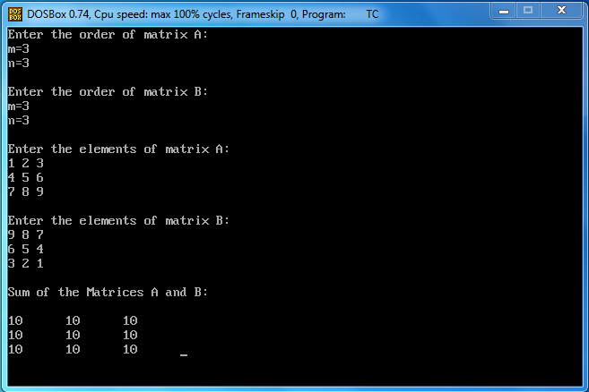

**CONCLUSION:** Hence, the program was successful, and the sum of any 3*3 matrix was found using dynamic memory allocation.